Sussex Community Dermatology Service
Administration Office
51 Chesswood Road
Worthing
West Sussex
BN11 2AG

Patient Helpline: 01903 703270
Fax: 01903 340849
Email:

Dear Patient,
Sussex Community Dermatology Service is committed as a service to improving patient care and patient experiences; we are therefore inviting you to take part in our Patient Participation Group.
If you would like to be involved and meet the criteria below, please contact us by one of the following methods:
Telephone: 01903 703270
Email:
Or visit us at: Worthing Laser & Skin Clinic
51 Chesswood Road
Worthing
West Sussex
BN11 2AA
Criteria:
- At least sixteen years old
- A previous or current patient of Sussex Community Dermatology Service
- Be able to attend regular meetings throughout the year
- Be contactable by email
- Have an interest in offering your opinion, suggestions and feedback
We look forward to hearing from you,
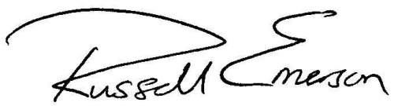

Dr Russell Emerson FRCP DM MB ChB Grace Hancock
Consultant Dermatologist & Clinical Director Assistant Service Manager

